TITLE: AIR QUALITY ANALYSIS IN TAMIL NADU

PHASE 3: DEVELOPMENT PART ONE

Importing Libraries

import numpy as np

import pandas as pd

import seaborn as sns

from sklearn.preprocessing import Imputer

import matplotlib.pyplot as plt

%matplotlib inline

plt.rcParams['figure.figsize'] = (10, 7)

from sklearn.model_selection import train_test_split

from sklearn.linear_model import LinearRegression

from sklearn.metrics import mean_squared_log_error

from sklearn.metrics import mean_squared_error

from sklearn.metrics import r2_score, mean_squared_error

from sklearn.feature_selection import RFE

from sklearn.linear_model import Ridge

from sklearn.linear_model import Lasso

import statsmodels.formula.api as sm

from sklearn.model_selection import KFold

from sklearn.model_selection import cross_val_score

from statsmodels.regression.linear_model import OLS

from statsmodels.tools import add_constant

from sklearn.preprocessing import StandardScaler

from sklearn.linear_model import LogisticRegression

from sklearn.metrics import classification_report

from sklearn import metrics

from statsmodels.stats.outliers_influence import variance_inflation_factor

import warnings; warnings.simplefilter('ignore')

*NumPy can be used to perform a wide variety of mathematical operations on arrays. It adds powerful data structures to Python that guarantee efficient calculations with arrays and matrices and it supplies an enormous library of high-level mathematical functions that operate on these arrays and matrices.

* Pandas is a Python library used for working with data sets. It has functions for analyzing, cleaning, exploring, and manipulating data. The name "Pandas" has a reference to both "Panel Data", and "Python Data Analysis" and was created by Wes McKinney in 2008

*Seaborn is a library for making statistical graphics in Python. It builds on top of matplotlib and integrates closely with pandas data structures. Seaborn helps you explore and understand your data.

*Scikit-Learn, also known as sklearn is a python library to implement machine learning models and statistical modelling. Through scikit-learn, we can implement various machine learning models for regression, classification, clustering, and statistical tools for analyzing these models.

# Dataset Summary

### **Statistcal analysis of given dataset**

dataset=pd.read_csv('../input/data.csv',encoding="ISO-8859-1")

dataset.describe()

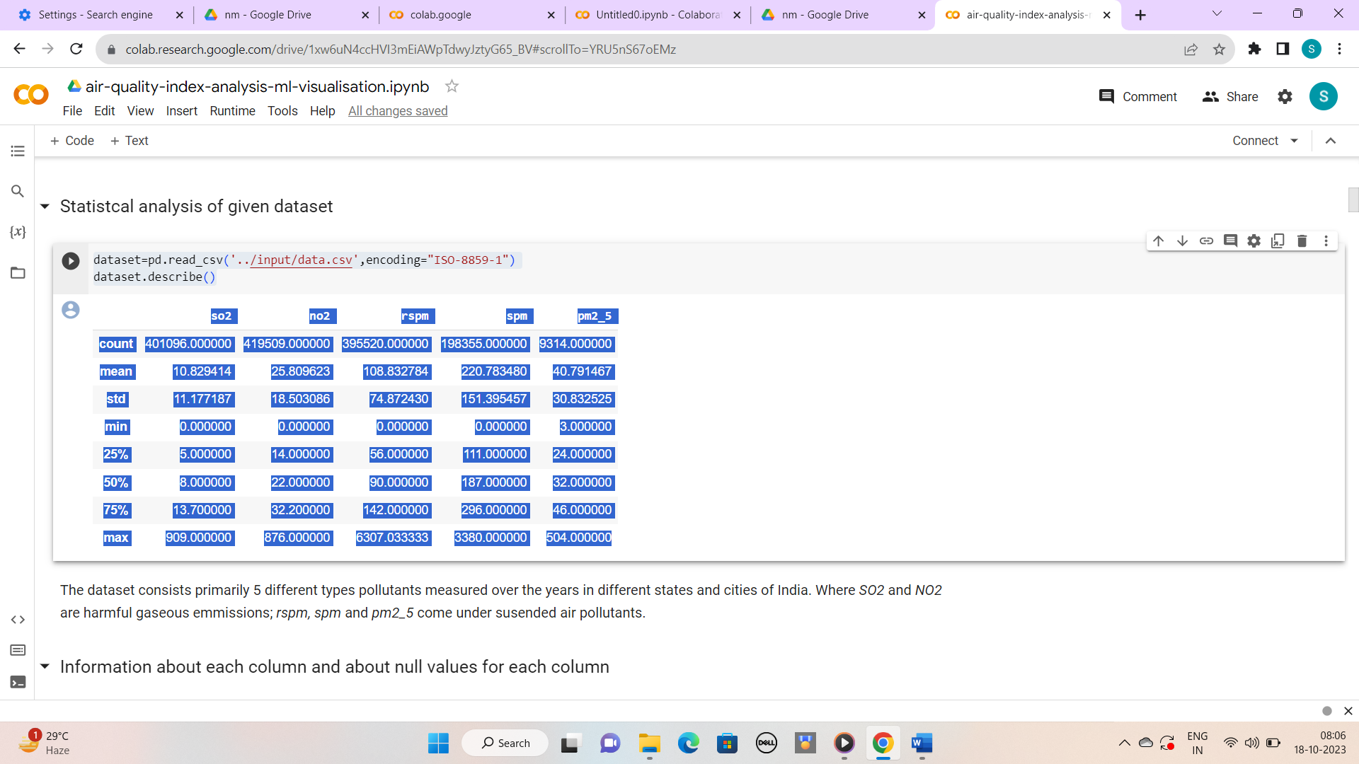

### **Information about each column and about null values for each column**

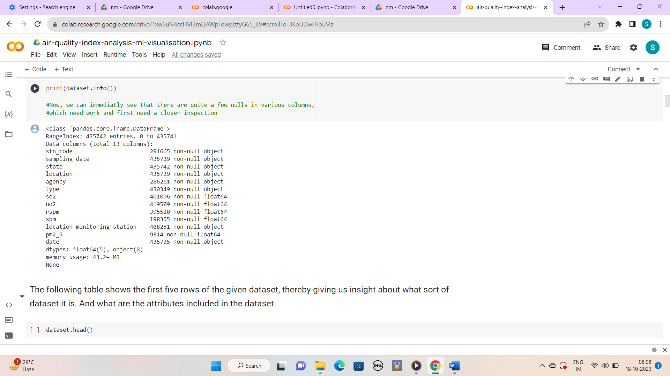

### **The following table shows the first five rows of the given dataset, thereby giving us insight about what sort of dataset it is. And what are the attributes included in the dataset.**

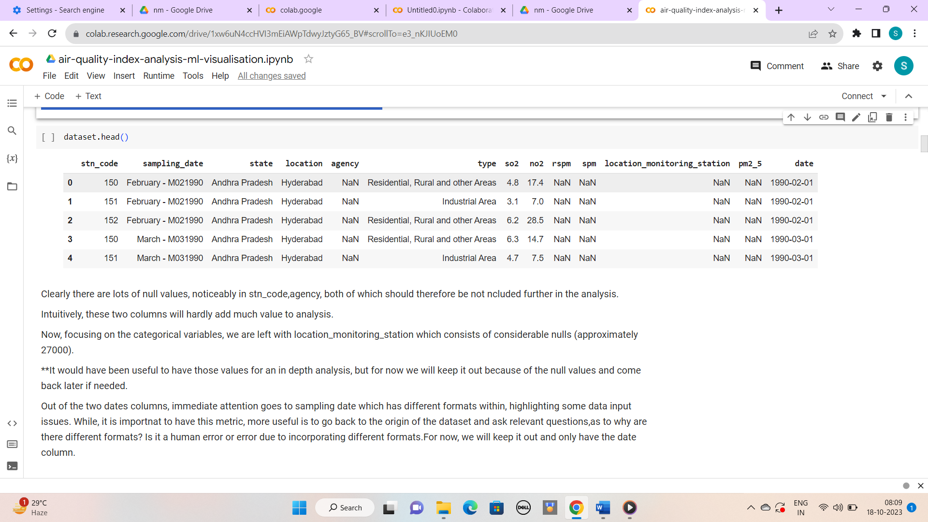

# Dataset Cleaning

### **Following tables gives information about new dataset after dropping of unneccessary columns**

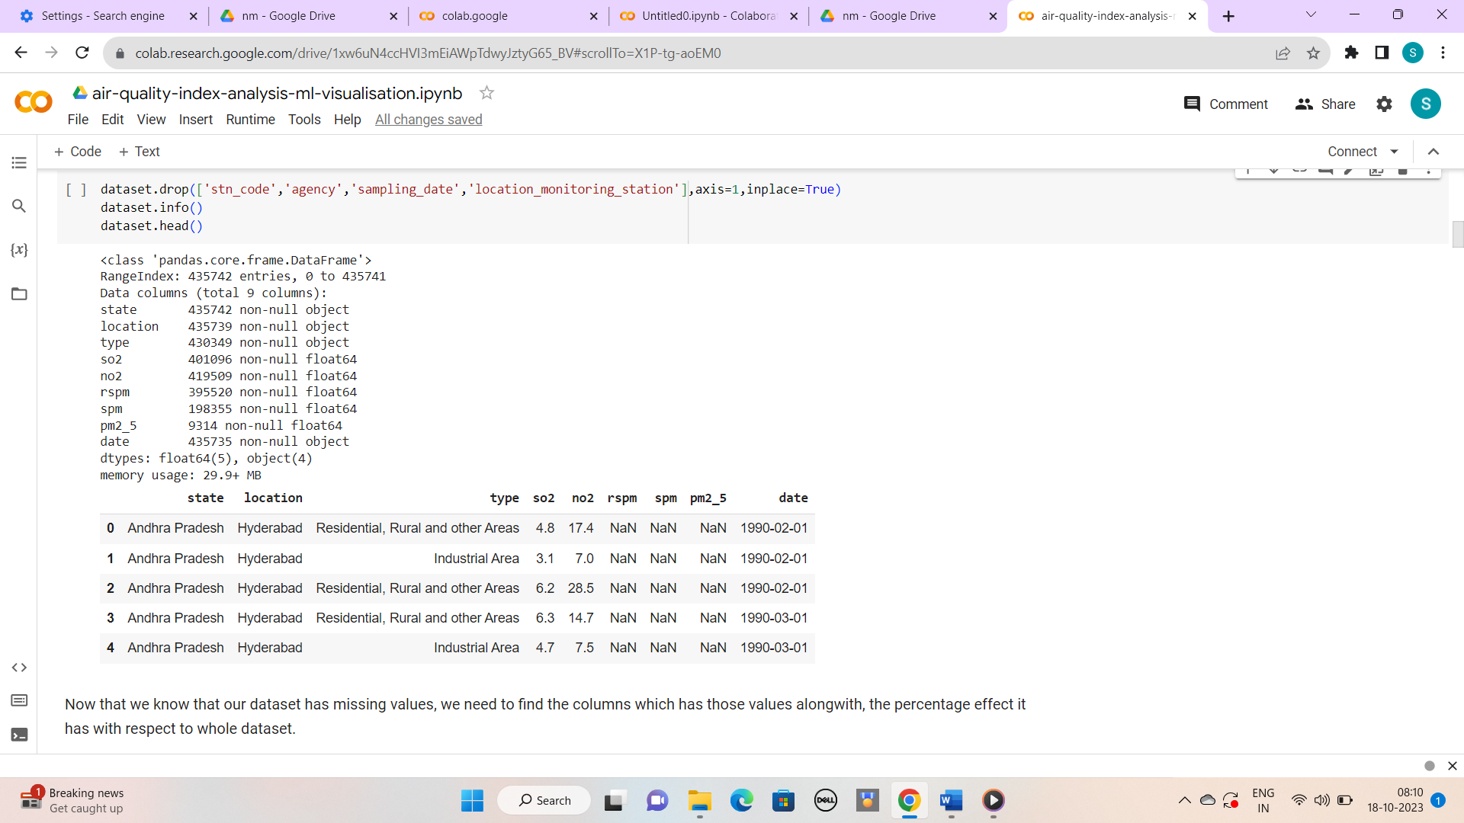

Often a DataFrame will contain columns that are not useful to your analysis. Such columns should be dropped from the DataFrame to make it easier for you to focus on the remaining columns. The columns can be removed by specifying label names and corresponding axis, or by specifying index or column names directly.

*code:

dataset.drop(['stn_code','agency','sampling_date','location_monitoring_station'],axis=1,inplace=True)

dataset.info()

dataset.head()

FINDING THE MISSING VALUES IN THE DATASET:

 If you are aiming for a job as a data scientist, you must know how to handle the problem of missing values, which is quite common in many real-life datasets. Incomplete data can bias the results of the machine learning models and/or reduce the accuracy of the model.

*CODE:

total = dataset.isnull().sum()[dataset.isnull().sum() != 0].sort_values(ascending = False)

percent = pd.Series(round(total/len(dataset)*100,2))

pd.concat([total, percent], axis=1, keys=['total_missing', 'percent'])

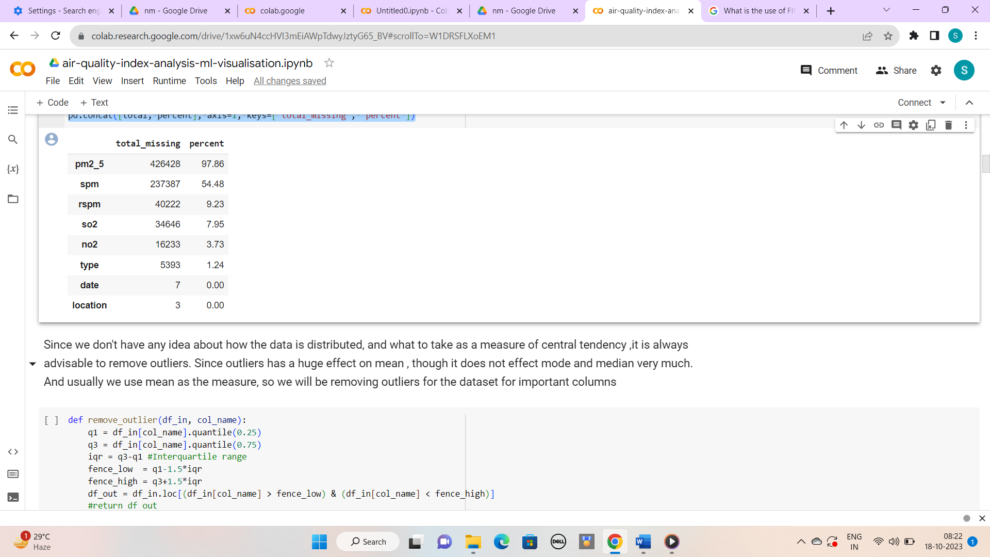

REMOVING OUTLIERS:

Outliers can distort statistical analyses and skew results as they are extreme values that differ from the rest of the data. Removing outliers makes the results more robust and accurate by eliminating their influence.

CODE:

def remove_outlier(df_in, col_name):

    q1 = df_in[col_name].quantile(0.25)

    q3 = df_in[col_name].quantile(0.75)

    iqr = q3-q1 #Interquartile range

    fence_low  = q1-1.5*iqr

    fence_high = q3+1.5*iqr

    df_out = df_in.loc[(df_in[col_name] > fence_low) & (df_in[col_name] < fence_high)]

    #return df_out

remove_outlier(dataset,'so2')

remove_outlier(dataset,'no2')

remove_outlier(dataset,'rspm')

remove_outlier(dataset,'spm')